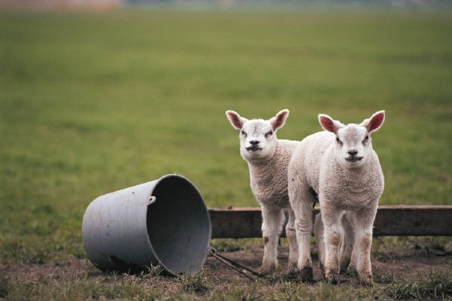
Spring Newsletter

Year 2

Dear Parents and Carers,

We hope you had a fantastic Christmas and that 2022 brings you all health and happiness. The children have returned full of enthusiasm for our new topics and have settled back into the daily routines of the day! The Spring Term brings new learning and some exciting adventures for everyone.

Grammar, Punctuation and Spelling
We will continue to use and apply capital letters and full stops accurately in our writing. Using question marks, exclamation marks and commas in lists will remain a focus too. We will explore when to use an apostrophe to show possession (Lily’s, Jack’s and Sally’s) and write contractions (I’m, We’ll and It’ll). Other GPS objectives will be shared in the reading record at the beginning of each half term and reinforced with homework activities throughout the year.

English
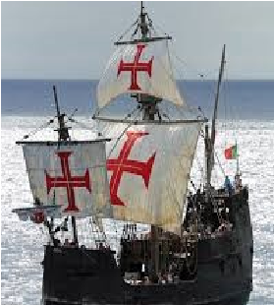
We will be exploring a range of different genres such as letter writing, instructions, recounts and character descriptions through topics such as Titanic and Explorers. We will be developing our understanding of vocabulary and how the author uses language to create atmosphere. We will develop our reading skills to retrieve and infer information in order to answer questions to show our understanding.

Maths
We will continue to consolidate our understanding of number bonds to 20 and 100, applying these facts to solve problems through a range of contexts. Year 2 will explore the mathematical topic of measuring mass, distance, length, volume, capacity, time and temperature. We will also explore Geometry focussing on the properties of 2D and 3D shapes as well as using positional language to describe quarter and half turns. All of these objectives will be challenging and children are encouraged to apply their understanding to solve problems whilst continuing to develop their knowledge of the 10, 5, 2 and 3 times tables.
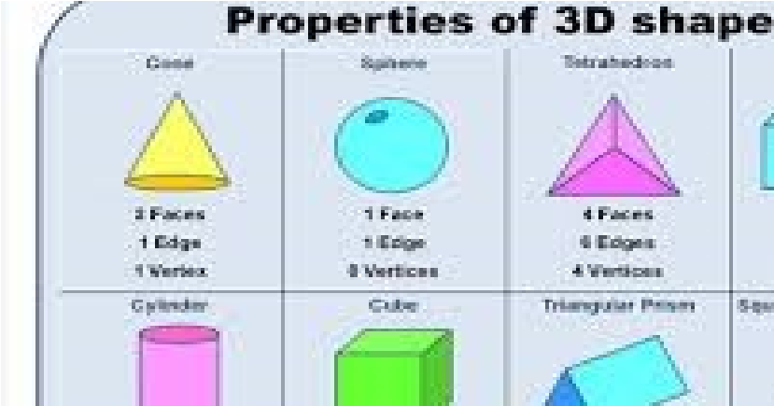
2.
The Creative Curriculum— History, Geography, Art & Design, Design

& Technology and Music

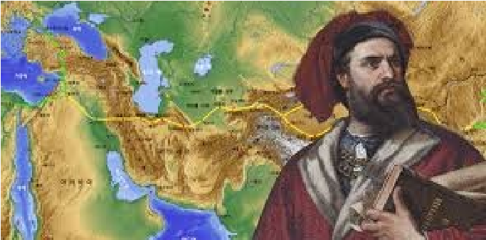
This half term we are learning about Titanic and why it is important in our history. All of our English objectives will be taught through this topic. Year 2 will read longer texts, identify unfamiliar words and clarify meaning. They will gather a range of vocabulary such as nouns, adjectives, verbs, adverbs and contractions. We will make a tea light holder in the style of George Hunter a local glass artist. Famous explorers such as Neil Armstrong and Christopher Columbus. Year 2 will read and find out about many interesting facts about these explorers and why they are famous in history. The children will plan, design, make and evaluate their own 3D rocket ship that meets specific design criteria.
Year 2 will continue to learn to play the ocarina to develop their understanding of musical vocabulary and sounds. Through this topic, the children will identify countries and oceans using the world map and begin their coding journey using the computing programme ’Scratch’.

Computing

Mrs Gregson continues to support teaching and learning in this curriculum area. The children will use their computing skills to research specific websites and learning resources and to retrieve, save and record information on their chosen explorer. They will also begin coding using a specific programme called ‘Scratch.’ This will link to their Creative Curriculum Topic.

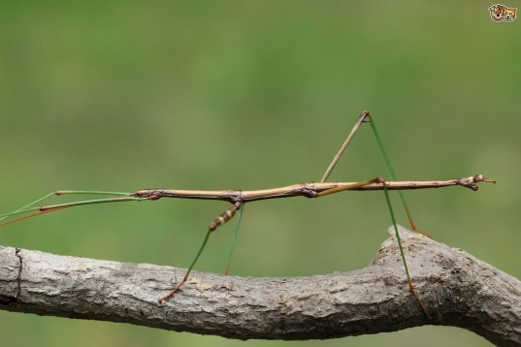

RE and Zippy’s Friends

We continue to explore our topic of ‘Books’ and how we use books in our everyday lives and how they can help us to learn more. Children will explore the Bible and its importance in the Christian faith and how the stories included help us to live our lives in the best way possible.

‘Zippy’s Friends’ is a specially designed programme that promotes positive mental health. The children will have the opportunity to discuss how they feel and how they cope with their emotions in different situations. Zippy is a stick insect that is a friend to everyone and helps us develop strategies to cope with our feelings. The children will explore this on a Friday afternoon with Mrs Gregson.

PE

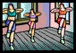
PE takes place with Mrs McMaster on a Wednesday morning. The children are developing their fitness skills and understanding how to maintain a healthy body and lifestyle.
Whilst most children come to school with long hair tied up to keep them safe, please could you make sure that your child has their hair tied up especially for PE. This is so all children can remain safe at all times. If your child wears ear-rings please can the ensure that they can take their ear-rings out or cover them with band-aids for that session to help prevent any accidents.

Science
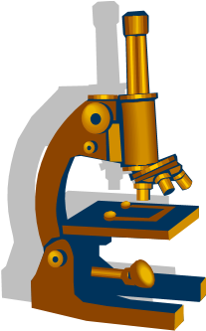
Mrs Roberts and Mrs Gregson have been investigating how to keep our bodies healthy and what supports a healthy lifestyle. Year 2 will develop their understanding of habitats, about their own habitat and the habitats of other animals and insects in our world.

Homework

Homework consists of reading, spellings and times tables/ number skills. Please can you hear your child read daily and write a comment in their reading record at least once per week to let us know how your child is reading at home. Spellings are shared each week for a challenge on a Friday alongside their weekly times table challenge. Please can you support your child to learn these. This is to help your child consolidate what they have been learning in school and prepare them for their journey into Key Stage 2. Year 2 children are also expected to access ‘Reading Eggs’ online at least once from home as well as Times Tables Rock Stars. This is monitored each week to support your child’s progress in these areas.

Many thanks for all of your help and support.

Mrs Clarke, Mrs Roberts and Mrs Gregson

